Jefferson Lague

Adeline Faye Lompon

IT64 (IT36A)

**Introduction**

The React and Ionic frameworks were used to create the straightforward ToDo list application that was produced. In addition to providing sign-up, login, and logout options for user authentication, users can add, amend, and remove ToDo items. User management and data storage are handled via Firebase Authentication and Firestore.

**Features**

**User Authentication:**

* **Sign Up:** Users can register for an account by providing their name, email, and password.
* **Login:** Users can log in to their accounts using their email and password.
* **Logout:** Users can log out of their accounts.

**Description of Your Works (Systems)**

**Login System (Login.tsx):**

* Provides a login interface where users can input their email and password.
* Authenticates users using Firebase Authentication.
* Checks if the user exists in Firestore, and redirects to the home page upon successful login.

**Sign-Up System (SignUp.tsx):**

* Provides a sign-up interface where users can register by providing their name, email, and password.
* Validates user inputs and displays appropriate error messages.
* Stores user data in Firestore upon successful sign-up.

**ToDo List Management System (ToDoList.tsx):**

* Displays a list of ToDo items fetched from Firestore.
* Allows users to add new ToDo items.
* Allows users to edit existing ToDo items.
* Allows users to delete ToDo items.
* Provides a logout button to allow users to log out of their accounts.

**Conceptual Framework**

The application is designed with a client-server architecture. React and Ionic are used to build the client-side, and Firebase services (Authentication and Firestore) handle server-side functions like data storage and authentication. To complete CRUD operations on ToDo items and authentication tasks, the client and server communicate.

**The System (Screenshot of your Output)**

**Login Display Screen Sign-Up Display Screen**

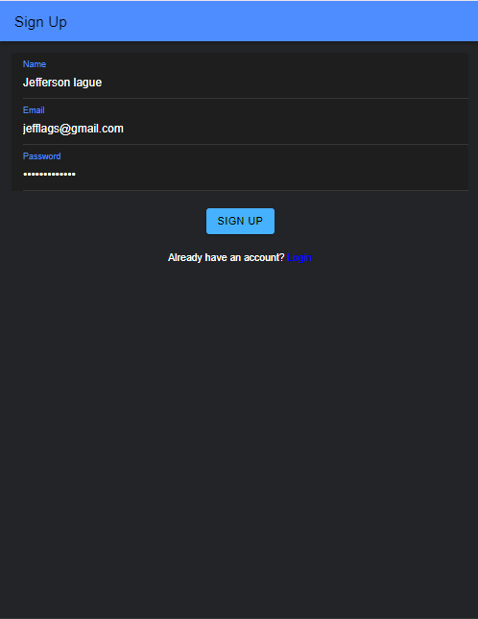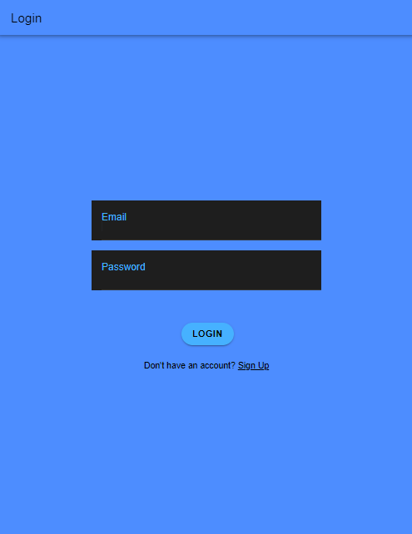

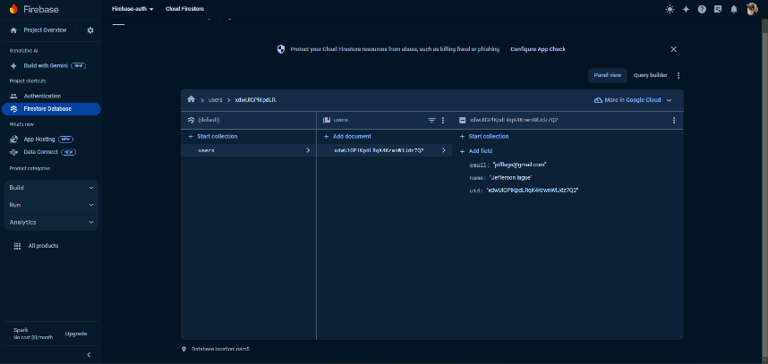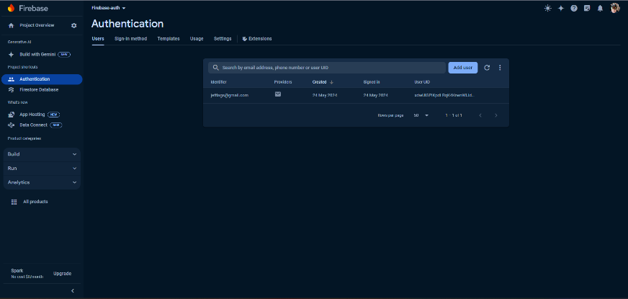**Firebase Display Screen**

**Reference:**

Lague, Jefferson. (2024, May). ToDo List Application. Retrieved from https://github.com/jefflags123/LAGUE-FINAL-PT